# Homework: Consuming Remote Data with JS and REST

This document defines the homework assignments from the ["JavaScript Applications" Course @ Software University](https://softuni.bg/trainings/coursesinstances/details/11). Please submit as homework a single zip / rar / 7z archive holding the solutions (source code) of all below described problems.

## Create "Books" REST Service

Register at **kinvey.com** and create an application. Create a class **Book(title, author, isbn)** to hold book objects. Fill a few sample books:

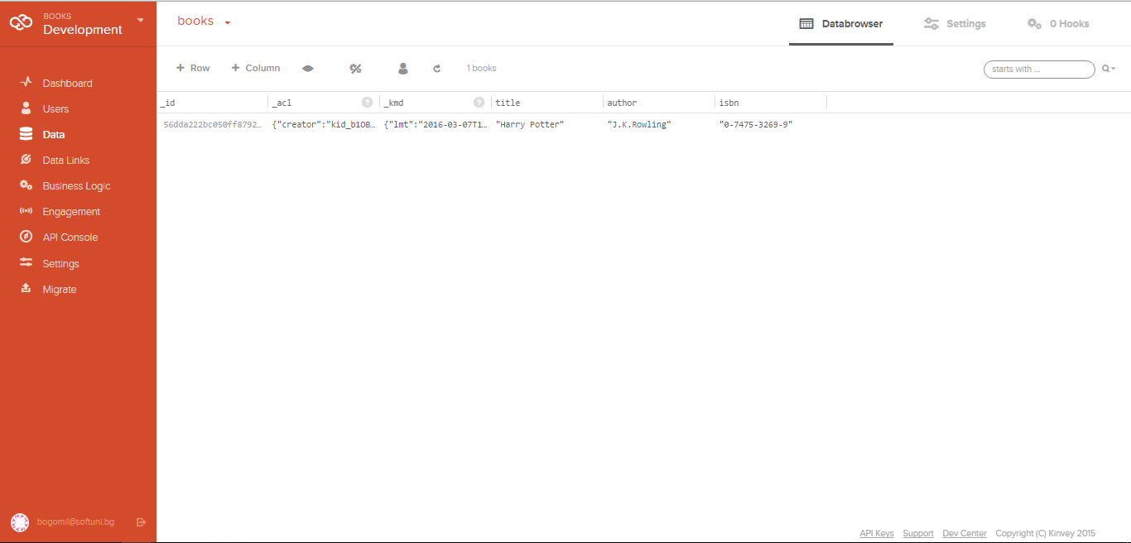

kinvey.com will automatically create the following REST services to access your data:

* **List All Books**
  + Endpoint: [https://baas.kinvey.com/apdata/[:appId]/books](https://baas.kinvey.com/apdata/%5b:appId%5d/books)
  + Method: GET
  + Headers:
    - Basic Authorization with **user credentials**
  + Returns (JSON)
* **Create a New Book**
  + Endpoint: [https://baas.kinvey.com/apdata/[:appId]/books](https://baas.kinvey.com/apdata/%5b:appId%5d/books)
  + Method: POST
  + Headers:
    - Basic Authorization with **user credentials**
    - Content-type: application/json
  + Request body (JSON): {"title":"…", "author":"…", "isbn":"…"}
* **Update a Book**
  + Endpoint: [https://baas.kinvey.com/apdata/[:appId]/books/[:bookId]](https://baas.kinvey.com/apdata/%5b:appId%5d/books/%5b:bookId%5d)
  + Method: PUT
  + Headers:
    - Basic Authorization with **user credentials**
    - Content-type: application/json
  + Request body (JSON): {"title":"…", "author":"…", "isbn":"…"}
* **Delete a Book**
  + Endpoint: [https://baas.kinvey.com/apdata/[:appId]/books/[:bookId]](https://baas.kinvey.com/apdata/%5b:appId%5d/books/%5b:bookId%5d)
  + Method: DELETE
  + Headers:
    - Basic Authorization with **user credentials**
    - Content-type: application/json

To view your kinvey.com access keys, go to your application dashboard 🡪 bottom-right menu 🡪 API keys:

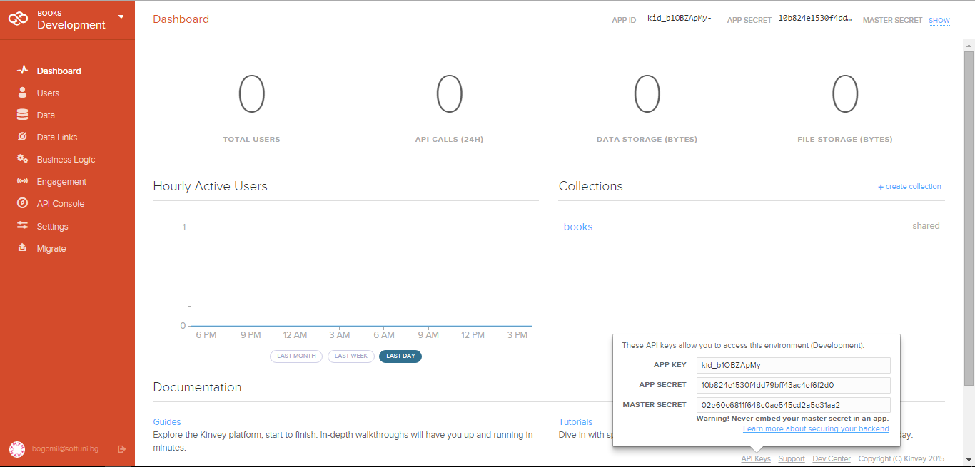

Test your REST Service, e.g. using **Postman** Chrome Extension (<http://www.getpostman.com>). Try to list all books in JSON format with an HTTP GET request to the REST API of kinvey.com.

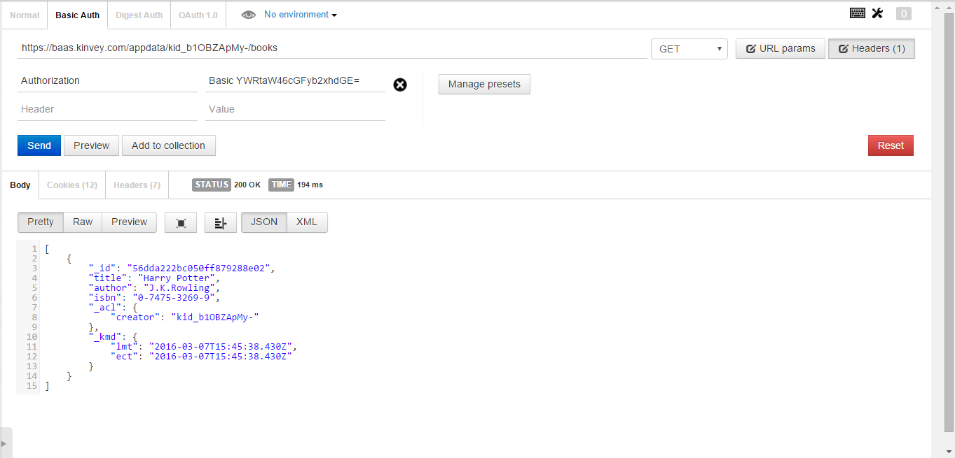

## List All Books

Create a HTML5 project consisting of HTML, CSS and JS files. Add an AJAX call that takes all books from your application in kinvey.com as JSON object and displays them at page load.

## Create a Book

Add a HTML form with submit button for adding a new book. When the button is pressed, create a new book at kinvey.com using its REST API with an AJAX request.

## Edit a Book

Implement "Edit a Book" functionality. Clicking on a book should load its data in a HTML form. By clicking the submit button, the book data at kinvey.com should be updated at the server side with and AJAX request.

## Delete a Book

Implement "Delete a Book" functionality. Each book should have "Delete" button. Clicking on it should delete the book at the server side with and AJAX request to the REST service.

## * Add Tags for Each Book

Implement tags for the books. Tags should be stored at kinvey.com in the Book class in a column "**tags**" as arrays of strings. List the tags for each book. Implement add / edit / delete for tags when a book is created / updated.